**Lab Report-02**

|  |  |
| --- | --- |
| **Course Code:** | **Course Title:** |
| CSE 416 | Web Engineering Lab |

|  |  |
| --- | --- |
| **Lab Report Details** | |
| Lab Perform Date | : 26/05/2025 |
| Report Submission Date | : 02/06/2025 |

|  |  |  |
| --- | --- | --- |
| **Submitted To** | **Submitted By** | |
| **Ms. Nishat Sadaf Lira**  Lecturer  Department of CSE  Daffodil International University. | Name  SID  Section  Daffodil | : Munna Biswas  : 221-15-5261  : 61-J2  International University |
|  | |

**Experiment No: 02**

**Experiment Name:** Styling and Layout Techniques for Web Pages Using CSS.

**Objective:**

To apply modern CSS styling and layout techniques to create a responsive, well-structured, and visually appealing coffee shop web page. This includes the use of Flexbox, Grid layout, typography, colors, responsive design, and hover effects.

**Overview of CSS Styling and Layout Techniques:**

| **No.** | **Feature Name** | **Description** | **Key CSS Properties / Techniques** |
| --- | --- | --- | --- |
| 1 | Header Styling | Styles the header with background color, text alignment, and padding. | background-color, text-align |
| 2 | Navigation Bar | Creates a horizontal navigation bar with hover effects. | display: flex: hover |
| 3 | CSS Grid Layout | Arranges the main content and sidebar using CSS Grid. | display: grid, grid-template-columns |
| 4 | Coffee Card Styling | Design product cards with padding, border-radius, and shadow. | padding, border-radius, box-shadow |
| 5 | Responsive Design | Adjusts the layout for smaller screens. | @media queries |
| 6 | Hover Animations | Adds a smooth zoom-in effect on coffee cards and images. | transform, transition |

**1. Header Styling**

**Description:**Applied background color, padding, and text alignment to make the header visually attractive.

**CSS Snippet:**

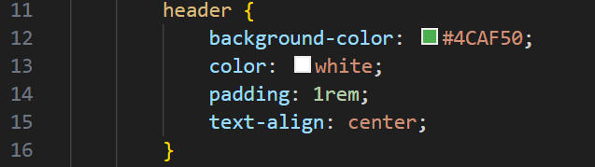

**Screenshot:**



**2. Navigation Bar**

**Description:**

Created a horizontal navigation bar with centered links and hover color change.

**CSS Snippet:**

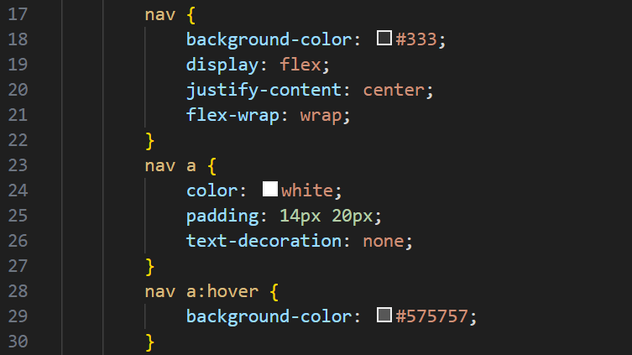

**Screenshot:**



**3. CSS Grid Layout for Main Section**

**Description:**  
Used CSS Grid to arrange main content and sidebar in two columns.

**CSS Snippet:**

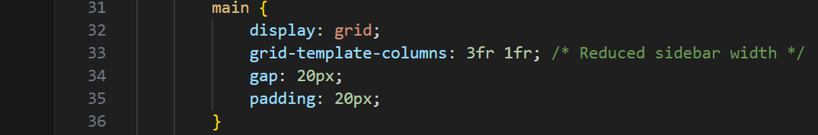

**Screenshot:**

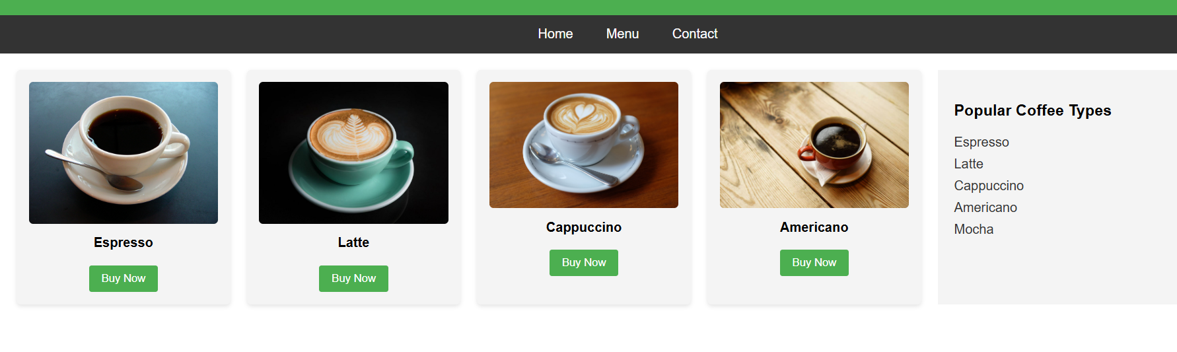

**4. Coffee Card Styling**

**Description:**

Designed coffee item cards with padding, rounded corners, and drop shadow for a modern look.

**CSS Snippet:**

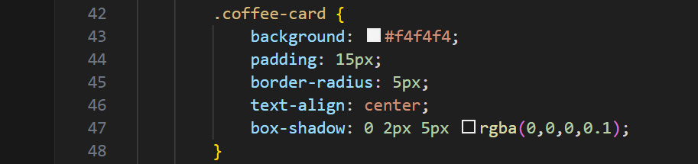

**Screenshot:**

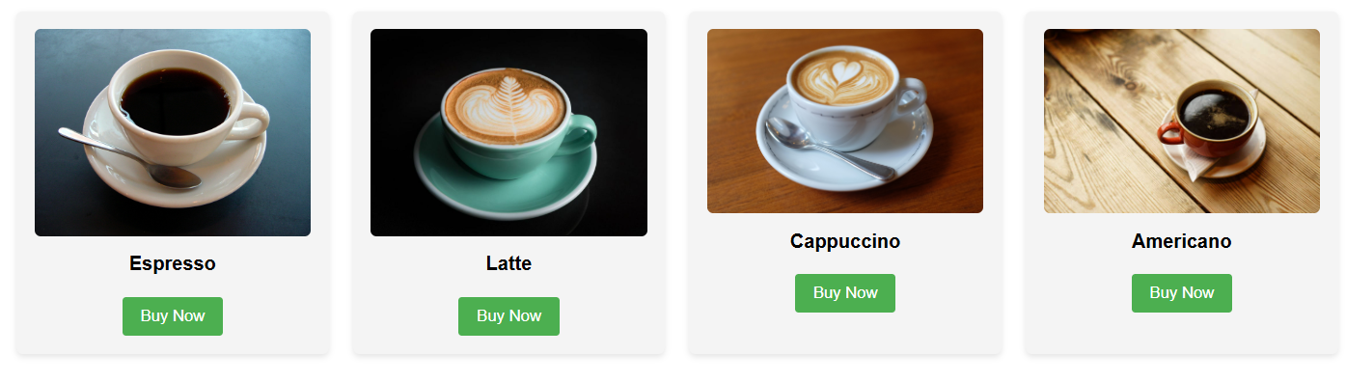

**5. Responsive Design (Media Queries)**

**Description:**Ensured the page adapts to smaller devices by changing layout to single column.

**CSS Snippet:**

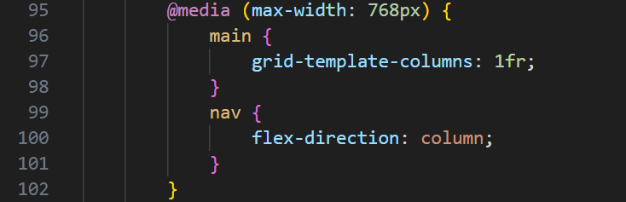

**Screenshot:**

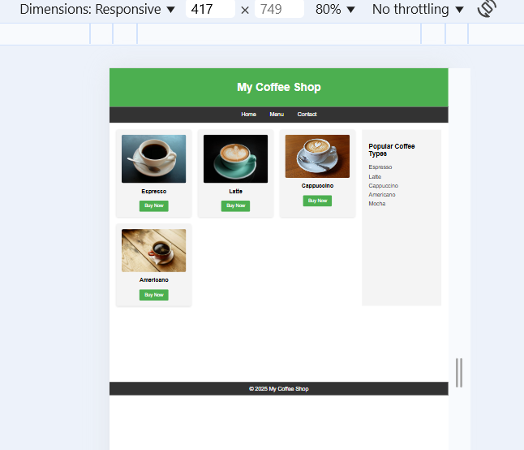

**6. Hover Animations**

**Description:**

Added a smooth zoom-in effect when hovering over coffee cards and images.

**CSS Snippet:**

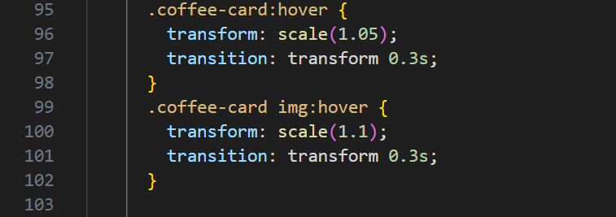

**Final Output:**

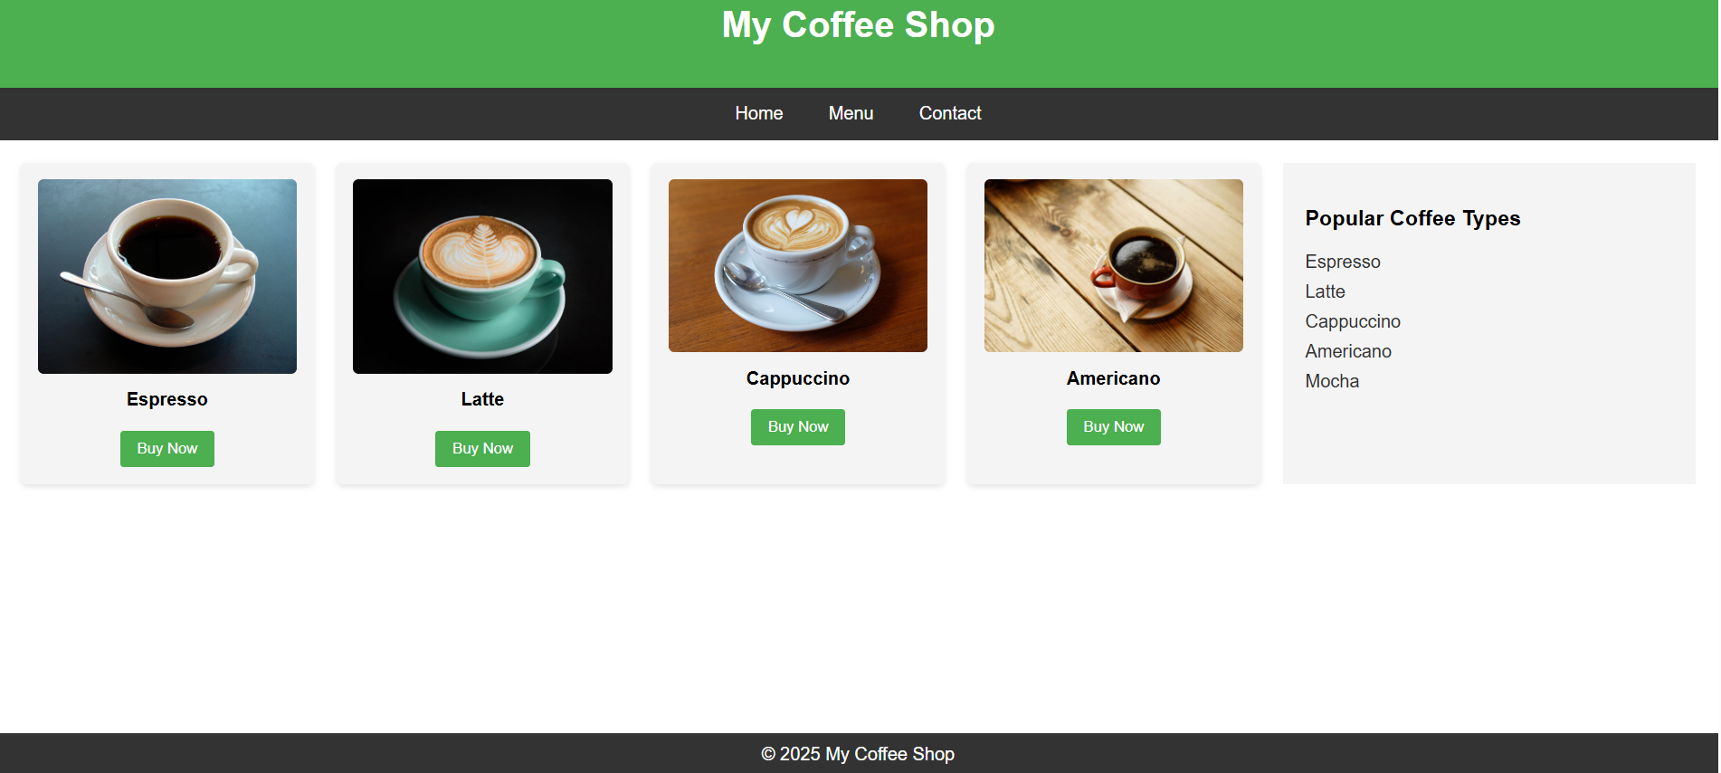

**Outcome:**

CSS styling and layout techniques such as Grid, Flexbox, and media queries allow developers to create attractive and responsive web pages. Hover animations and proper typography enhance usability and design aesthetics.

**Conclusion:**

By using CSS selectors, layout properties, and responsive techniques like Flexbox, Grid, and Media Queries, we created a well-structured and visually appealing webpage. The design adapts to different screen sizes, ensuring accessibility and user-friendliness across devices.

**References:**

<https://developer.mozilla.org/en-US/docs/Web/CSS>

<https://www.w3schools.com/css/>

<https://css-tricks.com/snippets/css/a-guide-to-flexbox/>